**APPLICATION PROJECT OUTPUT**

**Running in Terminal**

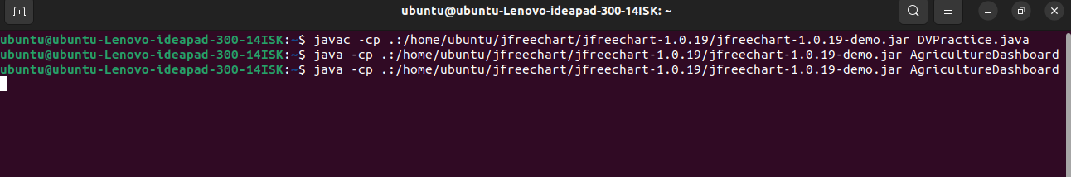

**Landing page regarding the topic**

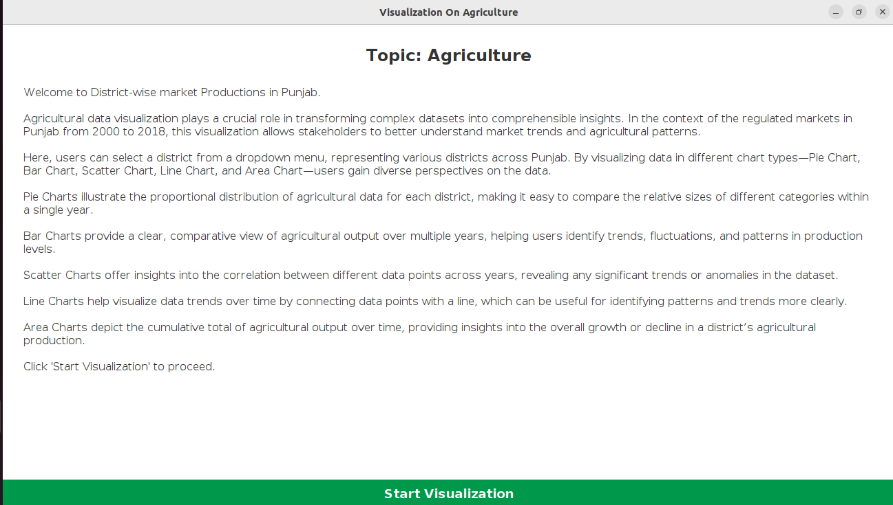

by clicking on Start Visualization

We can see the home page where i have defined space for story telling and view data of my charts

Here, users can select a district from a dropdown menu, representing various districts across Punjab. By visualizing data in different chart types—Pie Chart, Bar Chart, Scatter Chart, Line Chart, and Area Chart—users gain diverse perspectives on the data.

Pie Charts illustrate the proportional distribution of agricultural data for each district, making it easy to compare the relative sizes of different categories within a single year.

Bar Charts provide a clear, comparative view of agricultural output over multiple years, helping users identify trends, fluctuations, and patterns in production levels.

Scatter Charts offer insights into the correlation between different data points across years, revealing any significant trends or anomalies in the dataset.

Line Charts help visualize data trends over time by connecting data points with a line, which can be useful for identifying patterns and trends more clearly.

Area Charts depict the cumulative total of agricultural output over time, providing insights into the overall growth or decline in a district’s agricultural production.

**HOME Page**

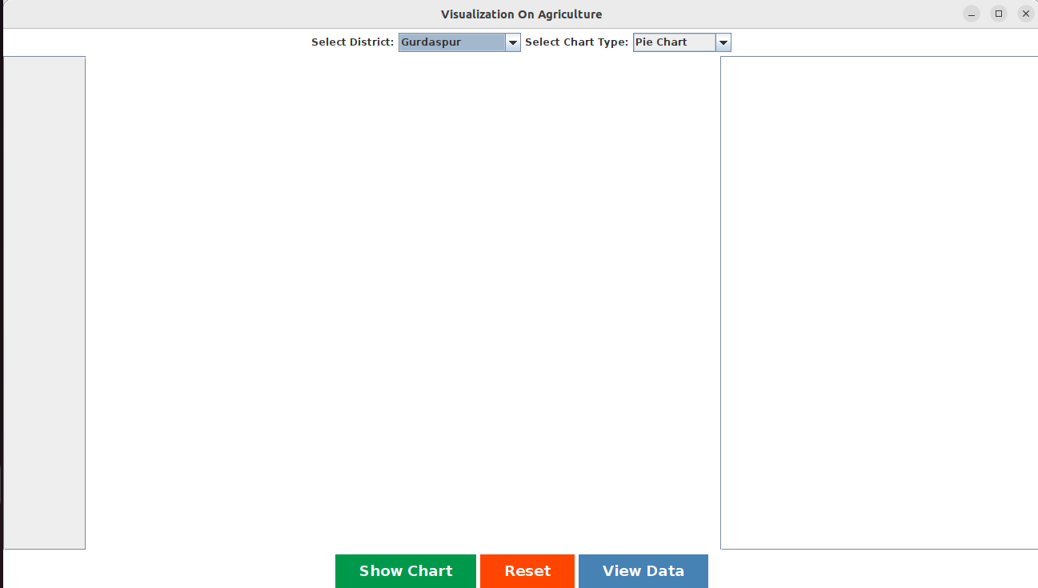

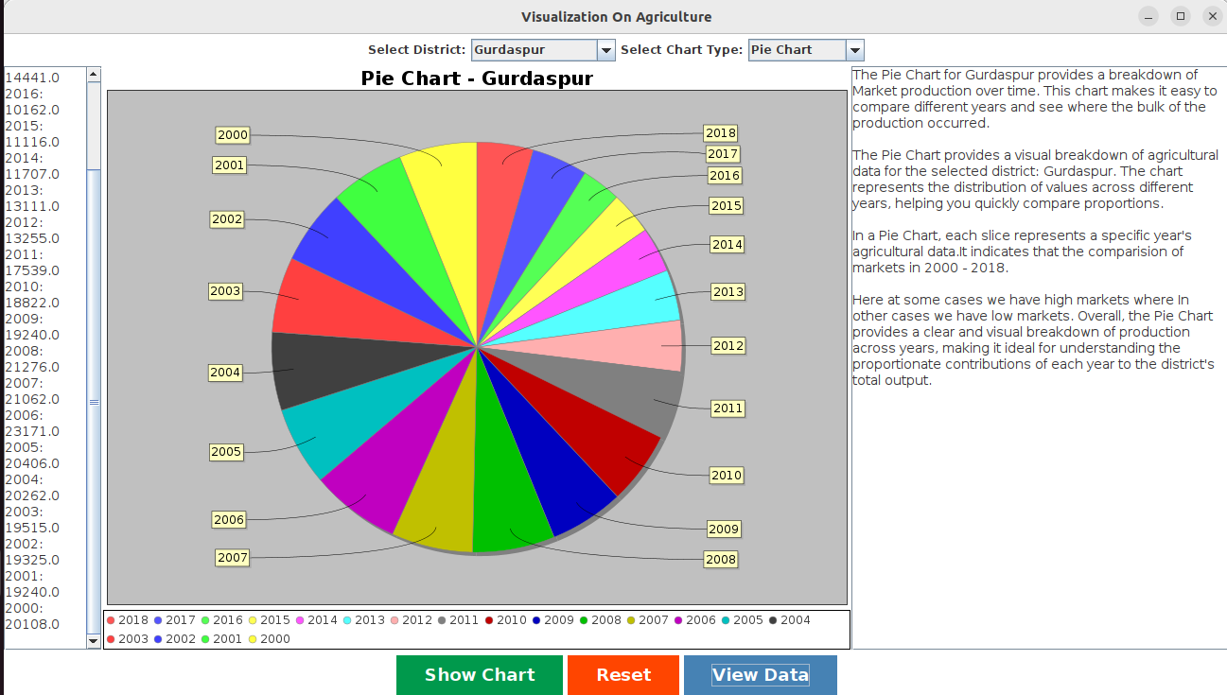**Pie chart with storytelling and with data of each districts**

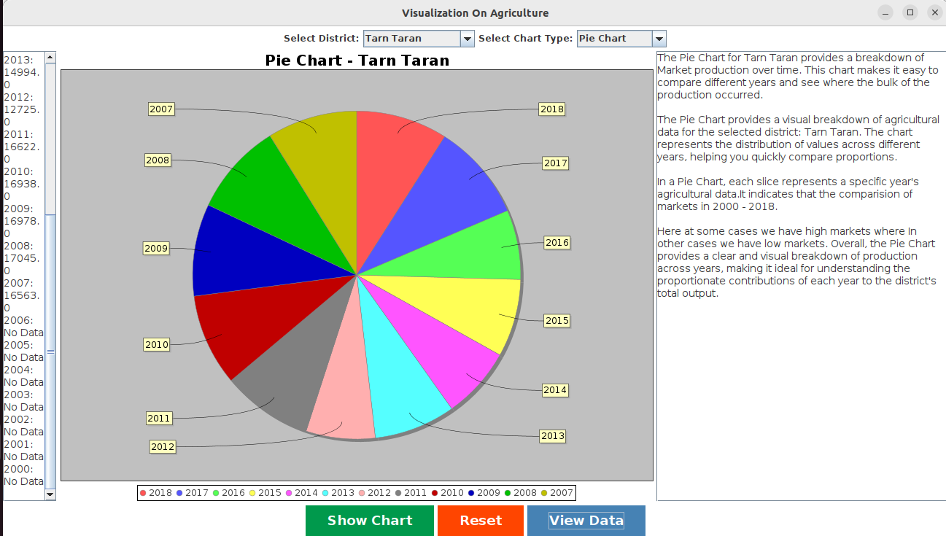

**Bar chart**

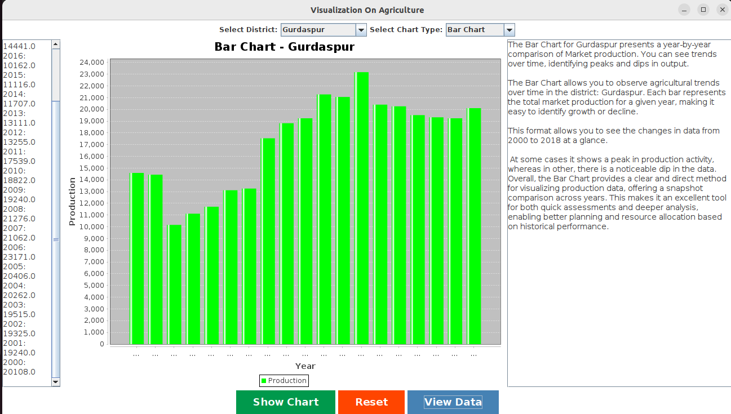

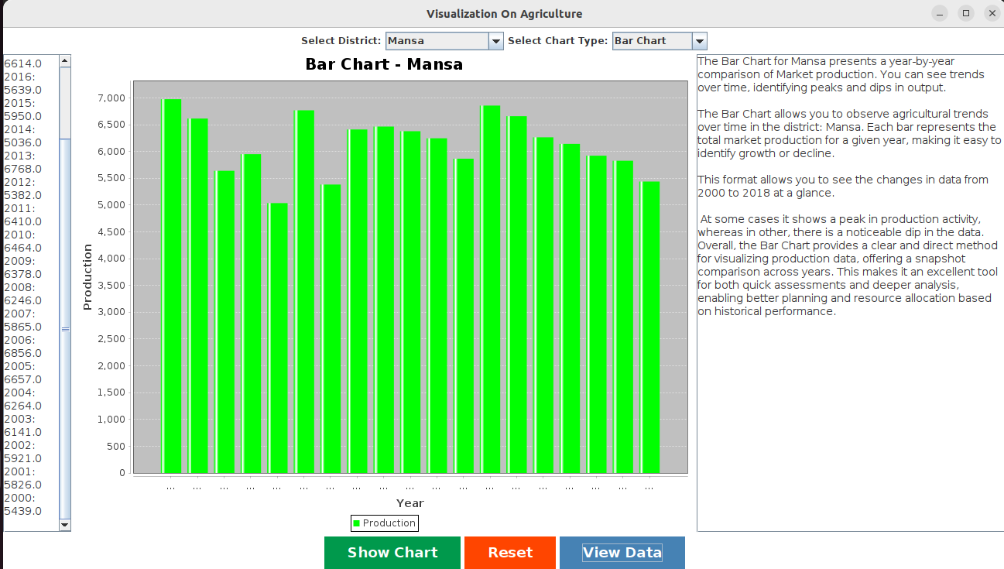

**Scatter plot**

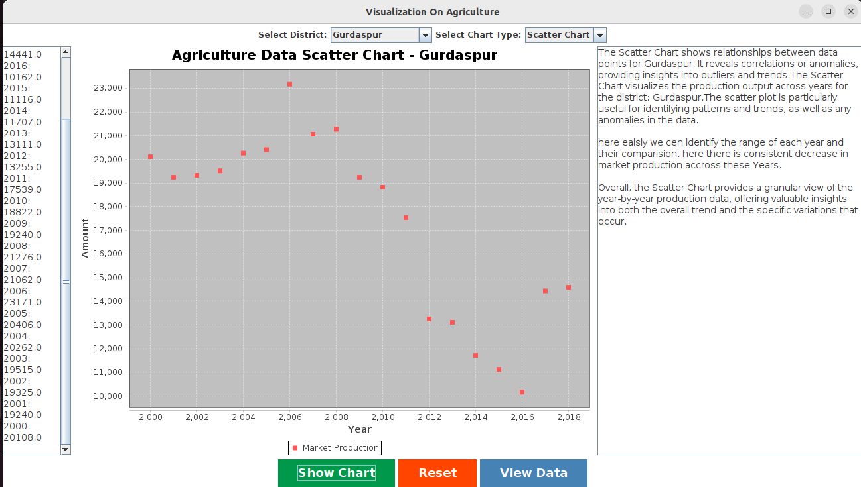

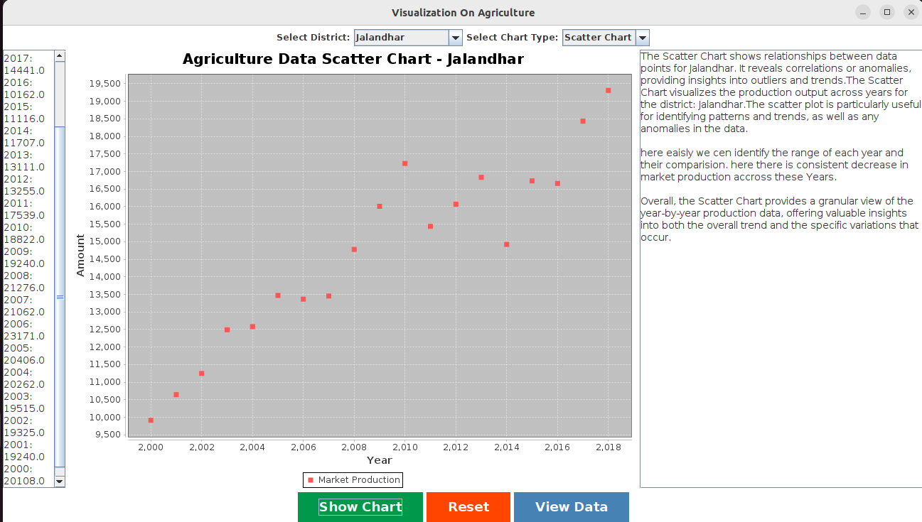

**Line chart**

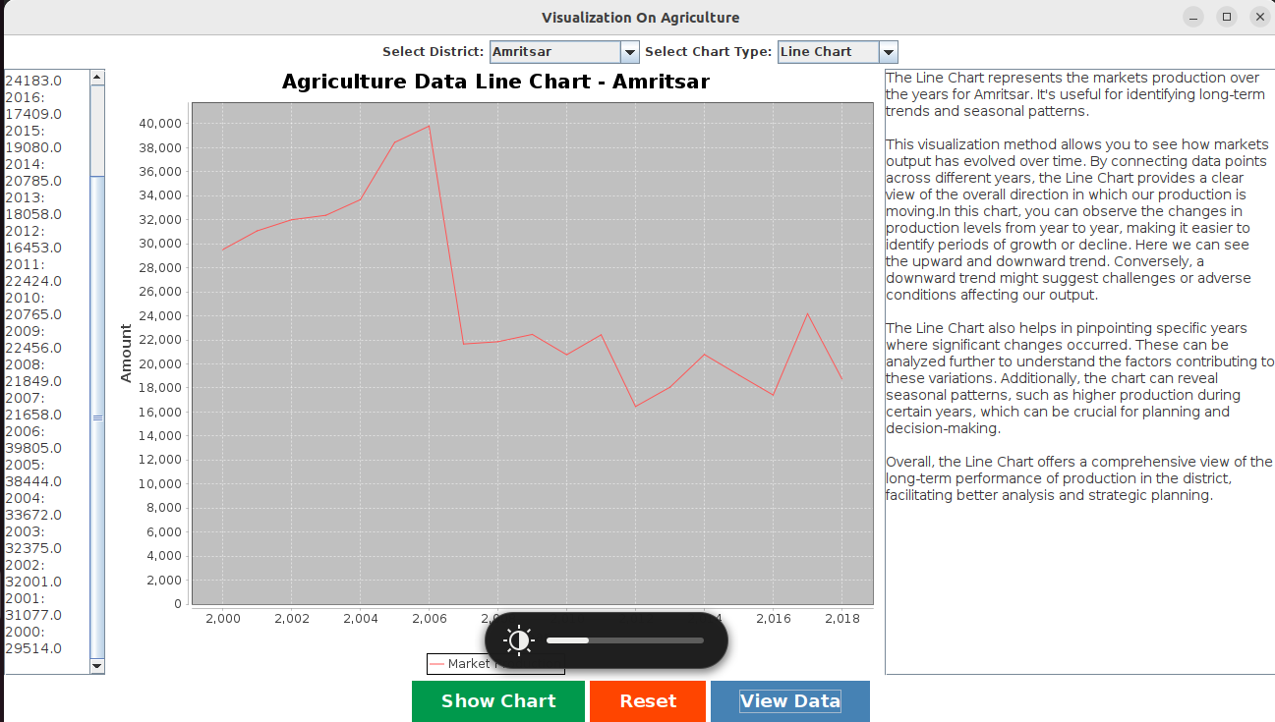

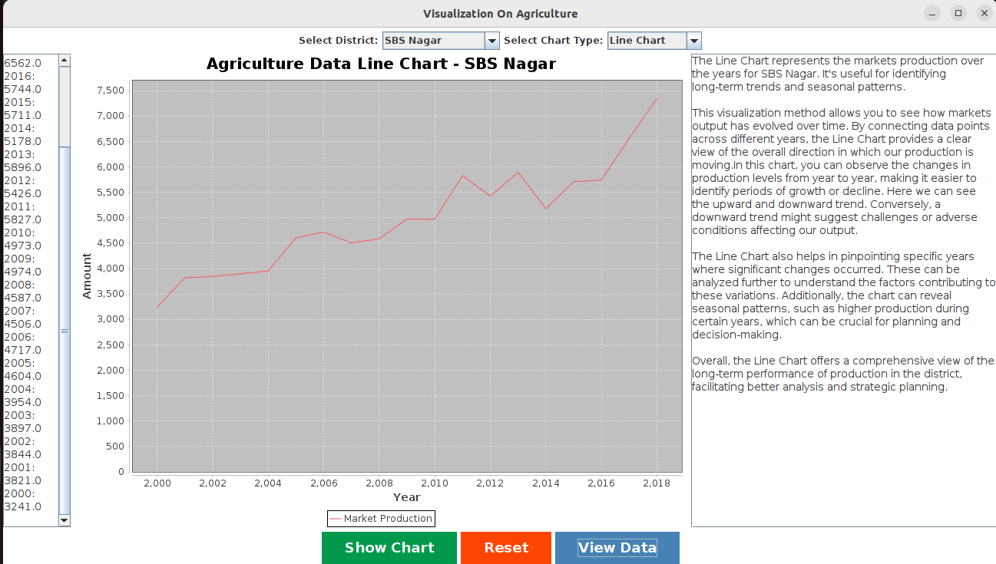

**Area Chart**

